Article Title
Author¹ Author^{2 *}
¹Affiliation; ^{2*}Affiliation
Email (Note: * Corresponding author)

Abstract
This sample document provides the authors with instructions to prepare the full paper for the conference. The abstract should summarize the contents of the paper within 100 to 250 words, written in English, A4 paper, single-spaced, justified, with a font size of 12pt Times New Roman. Please leave 2.5cm for top, bottom, left and right margins. The title should be written centered in 16pt boldface Times New Roman, initial capital letters. The authors’ names, affiliations, and e-mail addresses should be written centered in 12pt Times New Roman. Please do not number the pages for your paper. The format of the files should be in WORD format, and do not encrypt the document.

Keywords: No more than five.

Formatting
- All pages should be numbered sequentially.
- Tables should be included at the end of the manuscript and numbered in the order in which they appear in the text with appropriate captions. Figures should be treated similarly.
Because of space issues (i.e., desired number of pages per article and per issue), we ask that authors consider carefully the number of tables, figures and appendixes included in the paper. An excessive number of tables/figures would lead to a rejection out of concern for the number of pages these consume.

Length of manuscript
Authors should include the final word count on the first page of their manuscript. A typical manuscript will not exceed 7,000 words, including tables, references, captions and endnotes. Manuscripts exceeding this limit will be rejected.

Paper structure
Papers should be prepared in the following order:
Introduction: to explain the background work, the practical applications and the nature and purpose of the paper.
Body: to contain the primary message, with clear lines of thought and validation of the techniques described.
Conclusion
Acknowledgements (when appropriate)
References
Appendices (when appropriate)

General Guidelines
Section headings: should be left justified, with the first letter capitalized and numbered consecutively, starting with the Introduction. Sub-section headings should be in capital and lower-case italic letters, numbered 1.1, 1.2, etc., and left justified, with second and subsequent lines indented.
  - In-text citations
Here’s what an in-text citation looks like in a sentence:
- The author claims that “plagiarism is becoming a bigger problem” (Bandalos, 2002, p. 79).
- As Bandalos (2002) has shown, plagiarism is a serious issue for universities.
Table 1
Sample of In-text citation
Author type | First in-text citation | Subsequent in-text citations
No author | (“Title of the Work,” 2018) | (“Title of the Work,” 2018)
1 author | (Taylor, 2018) | (Taylor, 2018)
2 authors | (Taylor & Kotler, 2018) | (Taylor & Kotler, 2018)
3+ authors | (Taylor et al., 2018) | (Taylor et al., 2018)
Organization (identified through abbreviation) | (Centers for Disease Control and Prevention [CDC], 2018) | (CDC, 2018)
Organization (no abbreviation) | (Apple, 2018) | (Apple, 2018)
- In 2002, Bandalos found that plagiarism is becoming increasingly widespread

Tables
All tables should be numbered with Arabic numerals. Headings should be placed above tables, left justified. Leave one line space between the heading and the table. Only horizontal lines should be used within a table, to distinguish the column headings from the body of the table, and immediately above and below the table. Tables must be embedded into the text and not supplied separately (Hungerford, 1986).

Illustrations
All figures should be numbered with Arabic numerals (1, 2, …). All photographs, schemas, graphs and diagrams are to be referred to as figures. Line drawings should be good quality scans or true electronic output. Low-quality scans are not acceptable. Figures must be embedded into the text and not supplied separately. Lettering and symbols should be clearly defined either in the caption or in a legend provided as part of the figure. Figures should be placed at the top or bottom of a page wherever possible, as close as possible to the first reference to them in the paper. The figure number and caption should be typed below the illustration in 9pt and left justified.

Figure 1
Framing Scores for Different Reward Sizes

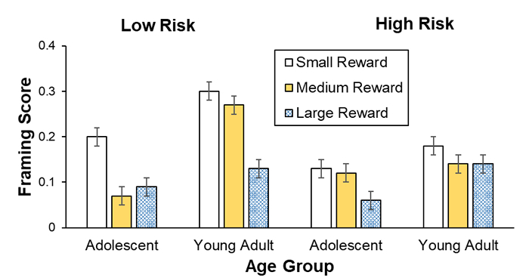
Note. Framing scores of adolescents and young adults are shown for low and high risks and for small, medium, and large rewards (error bars show standard errors).

Equations
Equations and formulae should be typed in Math type, and numbered consecutively with Arabic numerals in parentheses on the right hand side of the page (if referred to explicitly in the text). They should also be separated from the surrounding text by one space (Bland, 2017).

References
References should be formatted according to the Publication Manual of the American Psychological Association (APA).
Only essential references, which are directly referred to in the text, should be included in the reference list.
Journal references should include: author's surname and initials; initials and surnames of remaining authors; article title (where provided); abbreviated journal title (in italics), year of publication, volume number and page numbers (Chang & Wildt, 1994; Myer et al., 1964).
References to books should include: author's surname and initials; surnames and initials of remaining authors; the book title (in italics); the place of publication and the name of the publisher; and year of publication. References to multi-author works should include author's surname(s) and initials, the chapter title (where provided); "In:" followed by book title (in italics); initials and name(s) of editors(s) in brackets; volume number and pages; the place of publication and name of the publisher, followed by the year of publication.
Here is an example of some references listed according to the sequential system with APA 7 format:

Bandalos, D. L. (2002). The effects of item parceling on goodness-of-fit and parameter estimate bias in structural equation modeling. Structural Equation Modeling, 9(1), 78-102. https://digitalcommons.unl.edu/edpsychpapers/65
Bland, A. (2017, November). The implementation of a junior Samoan language programme in a South Island, New Zealand secondary school context [Paper presentation]. Australian Association for Research in Education (AARE) Conference 2017, Canberra, Australia. https://bit.ly/37DvrHR
Chang, T. Z., & Wildt, A. R. (1994). Price, product information, and purchase intention: An empirical study. Journal of the Academy of Marketing Science, 22(1), 16-27. https://doi.org/10.1177/0092070394221002
Hungerford, N. L. (1986). Factors Perceived by Teachers and Administrators as Simulative and Supportive of Professional Growth [Master Degree Thesis, State University of Michigan]. Elibrary. https://www.elibrary.ru/item.asp?id=7506582
Myers, R. H., Wong, K. L., & Gordy, H. M. (1964). Reliability Engineering for Electronic Systems. John Wiley.

