**Yuanjing Xue, M.B.A.**

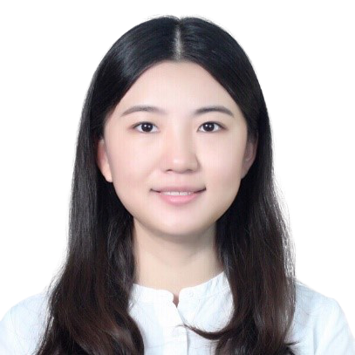

Lecturer, International Business

China-Asean International College (CAIC), Dhurakij Pundit University

110/1-4 Prachachuen Road, Laksi, Bangkok 10210, Thailand

Tel: +66 2954-7300 Fax: +66 2589-9605

Mobile: +66 959-126-555 E-mail: xue.yua@dpu.ac.th

**EDUCATION**

**2016:** M.S. in Business Administration, Assumption University

**2010:** B.A. in Flight Crew, Shanghai University of Engineering Science

**AREA OF EXPERTISE**

International Business; Cross-Cultural Communication; Philosophy and Religion

**TEACHING EXPERIENCE (selected list)**

**Full-time Lecturer**

|  |  |
| --- | --- |
| 2017-Presen | China-Asean International College (CAIC), Dhurakij Pundit University |
|  |

**RESEARCH EXPERIENCE (selected list)**

1. Xue,Y.J., Factors Affecting the Purchase Intention of Luxury Products: A Study of Chinese Tourists in Thailand, ICEMI, 2017