**XIANG YOU, PH.D.**

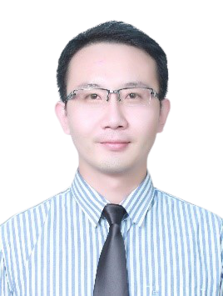

Deputy Dean of undergraduate Programs

China-Asean International College (CAIC), Dhurakij Pundit University

110/1-4 Prachachuen Road, Laksi, Bangkok 10210, Thailand

Tel: +66 2954-7300 Fax: +66 2589-9605

Mobile: +66 888-822-911 E-mail: xiang.you@dpu.ac.th

**EDUCATION**

**2020:** Ph.d. in Business Administration management, Dhurakij Pundit University

**20011:** Master's Degree, Faculty of Management of Organization Development (MMOD)

**2008:** Bachelor's Degree, Faculty of Communication Arts (CA) Advertising Major, Public Relation Minor.

**AREA OF EXPERTISE**

Cross culture Innovation Behavior; Organizational Behavior; Quantitative research

**TEACHING EXPERIENCE (selected list)**

**Full-time Lecturer**

|  |  |
| --- | --- |
| **2013-Present**  **2011-2013** | China-Asean International College (CAIC), Dhurakij Pundit University |
| Long March Group |
|  |  |

**RESEARCH EXPERIENCE (selected list)**

1. You Xiang, Dui Chen, Pengfei Chen (2018) Mental Health and Cross-Cultural Adaptation of Chinese International College Students in a Thai University International. Journal of Higher Education 7 (4), p133-142
2. You Xiang, Ajan LiHaofu, Ajan WangBo. (2018) A study of Total Quality Management on College Performance of Private Universities in Thailand: The mediating Effects of Market Orientation. ICTBS conference, p451-461
3. SMY Wen-Chuan WU, Ji QI, Xiang YOU (2017) A Study on Team Effectiveness for Entrepreneurism and Employee Creativity: Learning Goal Orientation as Moderator Variable ICEMI Bangkok,245-253
4. You Xiang (2011) A Study on the Relationship of Employees’ Motivation to Service, Job Satisfaction and Job Performance and propose ODI. ABAC Journal,12(3),362-371