**HAOFU LI, M.B.A.**

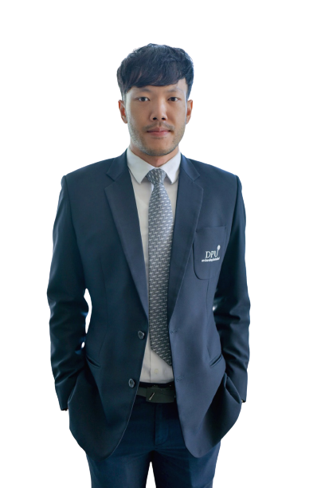

Head of Tourism Management, undergraduate program

110/1-4 Prachachuen Road, Laksi, Bangkok 10210, Thailand

Tel: +66 2954-7300 Fax: +66 2589-9605

Mobile: +66 816334121 Email: [haofu.li@dpu.ac.th](mailto:haofu.li@dpu.ac.th)

**EDUCATION**

6/2011 – 11/2013 Master of Business Administration in Integrated Marketing Communication (IMC), International College (DPUIC), Dhurakij Pundit University (DPU), Thailand

9/2005 – 6/2009 Bachelor of Arts (BA) in Hospitality and Tourism Management (IHOST), International College (DPUIC), Dhurakij Pundit University (DPU), Thailand

**AREA OF EXPERTISE**

Tourism CSR, Tourist behavior, Technology and innovative of mass market in tourism

**TEACHING EXPERIENCE (selected list)**

**Full-time Lecturer**

2014 – present CHINA-ASEAN International College (CAIC), Dhurakij Pundit University

**PUBLICATION / PROCEEDING (selected list)**

1. Li, H. & Zhang. H (2017). Motivation and Experience for Musical Arts: Situations at Outside Lands Music Festival. International Conference on Social Sciences, Arts and Humanities Bangkok, Thailand. 114-119.
2. You, X. & Li. H., (2019). Total Quality Management on hotel industry. The 1st CHINA-ASEAN International Conference 2019.
3. Li. H. & Wang, S., (2019). Corporate Social Responsibility Performance (CSR) and Perceived Brand Quality on Chinese Students-based Brand Preference in a Private University in Thailand. The 1st CHINA-ASEAN International Conference 2019