**DR. XIUGANG YANG**

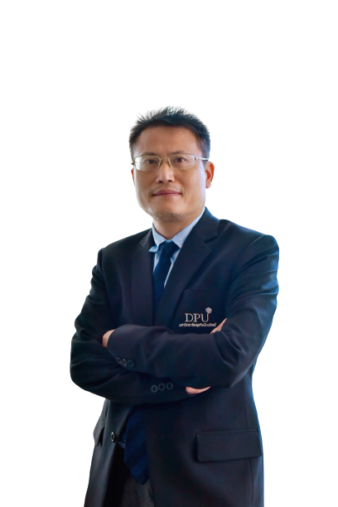

Instructor and Researcher

Research Innovation and Development (RDI)

Dhurakij Pundit University110/1-4 Prachachuen Road, Laksi,

Bangkok 10210, Thailand, Tel: +66 2954-7300 Fax: +66 2589-9605

Mobile: 0928156193 E-mail: yang.xiu@dpu.ac.th

**EDUCATION**

**2013**  Economics Doctor of Zhongnan University of Economics and Law

**2015** Philosophy Master of Hunan Normal University

**AREA OF EXPERTISE**

Economics, Management of Firms, Marketing and Finance

**TEACHING EXPERIENCE (selected list)**

**Full-time Lecturer**

2014-Presen

2005-2010 China-Asean International College (CAIC), Dhurakij Pundit University

Teaching in Hunan Women’s University

**PUBLICATION / PROCEEDING (selected list)**

1. Huaiming CHEN, Xiugang YANG (2015), A Study on Relationship of Micro-innovation, Customers’ Value and Brand attachment –on Base of Path of New Product Spread. Knowledge ECONOMY. (368),78-80.2015(10)
2. Yanshu TU, Xiugang YANG (2016), The Research About the Factors that Influence the Sales Volume and Props in Comic and Cosplay Industry, Times Finance, 2, 228-231.
3. Yang Xiugang(2017): “The Impact of Aesthetic Value on Economic Value in Clothing Fashion Show ”.The 2nd International Conference on Economics and Management Innovations (ICEMI 2017), Bangkok, Thailand. (15-16 July, 2017)
4. Huang Yi, &Yang Xiugang(2017). Investors’ irrational behaviors, stock-price fluctuation and enterprise inefficient investment. The 2nd International Conference on Economics and Management Innovations (ICEMI 2017), 1(1):106-108.
5. Huang Yi, &Yang Xiugang(2018). Managers’ overconfidence, risk preference, herd behavior and non-efficient investment. Independent Journal of Management & Economics,9(3).(ProQuest)
6. Huang Yi, & Yang Xiugang(2018). Investors’ Sentiment and Enterprise’s Non-Efficient investment: the Intermediary Effect of Stock Price Volatility. International Journal of Business and Social Research, 8(7), 01-14.(EBSCOhost)
7. Li Hongxia, & Xiugang Yang(2018). When a calling is living: job crafting mediates the relationships between living a calling and work engagement[J].Journal of Chinese Human Resource Management. July 2018.(Scopus)
8. Yang Xiugang(2019), The Analysis of Motivation Factor for Work Enthusiasm. The 1st China-ASEAN International Conference 2019 (3, April,2019)
9. YANG Xiugang(2020), An Empirical Study on Cultural Leisure Life Level Influence on

the Growth of Human Capital By Viewpoint of Leisure Economics, The 2ndChina-ASEAN International Conference 2020 and The 2nd International Conference on Tourism, Business, & Social Science 2020 The 2nd International Conference on Tourism, Business, & Social Science 2020

1. Xiugang YANG(2020),An Analysis on Motivation Factor for Work Passion, International Journal of Economics and Management Studies (SSRG-IJEMS) – Volume 7 Issue 3–March 2020, P152-162,
2. Xiugang YANG(2020),Cultural leisure life and Human Capital Growth: The evidence from China, International Journal of Economics and Management Studies (SSRG-IJEMS) – Volume 7 Issue 5–May 2020, P158-170
3. Xiugang YANG(2020), A New Frame of Transaction Capacity for Exchange of Knowledge Goods, International Journal of Economics and Management Studies (SSRG-IJEMS) – Volume 7 Issue 6–June 2020, P13-21
4. 杨秀刚、卢现祥：《制度质量与人类发展水平辩证关系的实证研究》[J]，《中国人口科学》，2013年第2期。（CSSCI，三类权威期刊）
5. 杨秀刚、戴冬阳：《论主权货币国际化对主权国股市繁荣的影响》[J]，《统计与决策》，2013年第16期。（CSSCI）
6. 杨秀刚、黄玉龙：《突发公共事件中金融市场价格与均衡价格的协整分析》[J]、《经济论坛》，2011年第5期。
7. 专著：《无形资产的制度经济学研究》[M]，湖南大学出版社，2013年8月。