**SHEN-YIN .LIU**

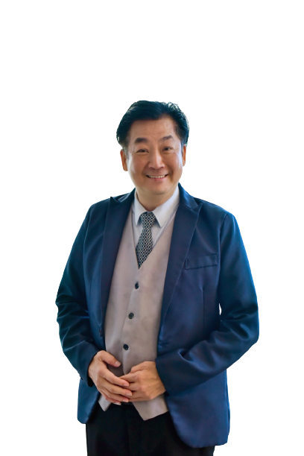

Bachelor of Business Administration (Tourism Management) Program

China-Asean International College (CAIC), Dhurakij Pundit University

110/1-4 Prachachuen Road, Laksi, Bangkok 10210, Thailand

Mobile: +66 065 970 8830

E-mail: liushenyin@gmail.com

**EDUCATION**

**September 2012:** Department of Tourism, School of Management, Xiamen University

Xiamen city of China   
**June 2007:** Department of Tourism, School of Management, Shih Hsin UniversityTaipei of Taiwan

**June 1986:** International Business College Banking and Insurance Department

Kaohsiung of Taiwan

**SCHOLARSHIPS**

**2005-2006** TransAsia Airways Lin Deng Culture and Education Foundation Education Scholarship

**AREA OF INTERESTS**

**Customer service :** Customer relationship management

**International**  International etiquette, reception etiquette, social etiquette...life etiquette

**etiquette**:

**Airport** Airport operation management, ground handling service management,

**management:** international airport contract processing and signing

**Cross Cultural** Cultural analysis and comparison integrates new environment and thinking

**Communication** from a cross-cultural perspective

**and Management:**

**TEACHING EXPERIENCE (selected list)**

**Full-time Lecturer**

|  |  |
| --- | --- |
| **2008-Present** | Lecturer **, Taipei Marine Science and Technology University** |