**SHIAN-HENG LEE, M.F.A.**

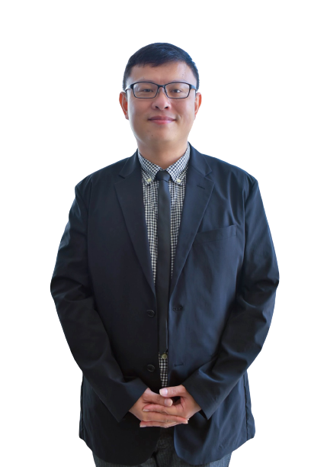

Lecturer, Art and Design

China-Asean International College (CAIC), Dhurakij Pundit University

110/1-4 Prachachuen Road, Laksi, Bangkok 10210, Thailand

Tel: +66 2954-7300 Fax: +66 2589-9605

Mobile: +66 820-621-015 E-mail: shian-heng.lee@dpu.ac.th

**EDUCATION**

**January 2004:** Master of FINE ARTS, Institute of Fashion Design, Shih Chien University, Taiwan  
**June 2001:** Bachelor of Arts, Department of Interior Design, Chung Yuan Christian University,

Taiwan

**AREA OF EXPERTISE**

**Interior design** Commercial space design

House space design

Exhibition space

**Fashion design** Creative fashion clothing

Fabric design

**TEACHING EXPERIENCE (selected list)**

**Full-time Lecturer**

|  |  |
| --- | --- |
| **2019-Present** | **China-Asean International College (CAIC), Dhurakij Pundit University, Thailand** |
| Undergraduate Art Aesthetics  Product Design Process  History of Eastern Art  Principles of Decorative Design  Research in Art and Design  Textile Design  Poster Design |
| **2007-2009** | **Department of Interior Design, Chung Yuan Christian University, Taiwan** |
| Undergraduate Basic Design (I) (II)  Interior Presentation  Interior Design (I) (II)  Chromatics  Design Ethics  Furniture design  Textile Design |

**Visiting Scholar/Guest Lecturer**

|  |  |
| --- | --- |
| **2009-2019** | **Department of Interior Design, Chung Yuan Christian University, Taiwan** |
| Undergraduate Interior Presentation  Chromatics  Textile Design |
| **2011-2019** | **Department of Architecture, China University of Science and Technology, Taiwan** |
| Undergraduate Interior Design (III) (IIIl)  Graduation Project |
| **2015-2015** | **Department of Interior Design, Tungnan University of Technology, Taiwan** |
| Undergraduate Interior Design (III) (IIIl)  Graduation Project |

**RESEARCH EXPERIENCE (selected list)**

* Shian-Heng Lee (2015). Sharing experience from study to teach in interior design.

2015 Magazine of the pioneers of Taiwan architectural scholars and architects, no:79, P36-39.

* Shian-Heng Lee (2013). Myth of cultural and creative industries at Fashion Institute of Taipei (Taipei Costume Cultural Canter).

2013 International Conference on Design Education and Industry-Academic Collaboration, Taichung, Taiwan.

**RELATED LICENSES (selected list)**

* Level B technician for interior design of building
* Level B technician for decoration & repairs management of building