**HAO CHEN, M.B.A.**

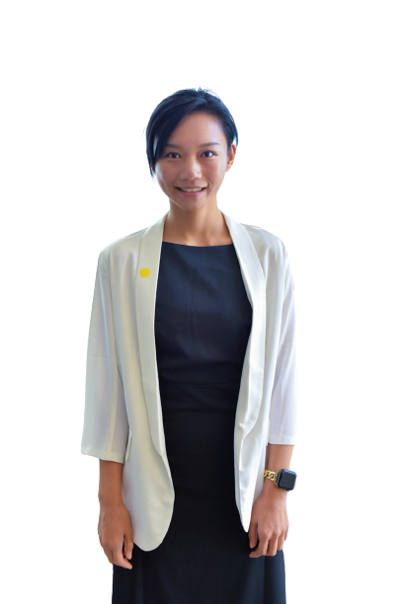

Lecturer, International Business Department

China-Asean International College (CAIC), Dhurakij Pundit University

110/1-4 Prachachuen Road, Laksi, Bangkok 10210, Thailand

Tel: +66094172-0724

Mobile: +66094172-0724 E-mail: hao.che@dpu.ac.th

**EDUCATION**

**July 2018:** Master in Business Administration, Dhurakij Pundit University, Bangkok , Thailand  
Major: MBA

**June 2015:** Bachelor of Tourism and Culture College of Yunnan University

Major: Marketing

**AREA OF EXPERTISE**

**Behavior:**  Consumer behavior

**Behavior:** Organizational behavior

**TEACHING EXPERIENCE (selected list)**

**Full-time Lecturer**

|  |  |
| --- | --- |
| **2019-Present** | **China-Asean International College (CAIC), Dhurakij Pundit University** |
| Undergraduate Operations Management  Business Laws and Ethics  Supply Chain Management |
|  |  |

**RESEARCH EXPERIENCE (selected list)**

* Hao Chen, Chun-shuo Chen (2019) The Influence of Job Stress and Workplace Networking Behavior on Job Satisfaction: The Moderating Effect of Emotional Intelligence. China-ASEAN International Conference, 286-296.
* Dan Su, Hao Chen (2020) The Influences of Pressure and Effort Input on Job Crafting. China-ASEAN International Conference,237-246.