**ASST. PROF.DR. YUAN-CHENG CHANG**

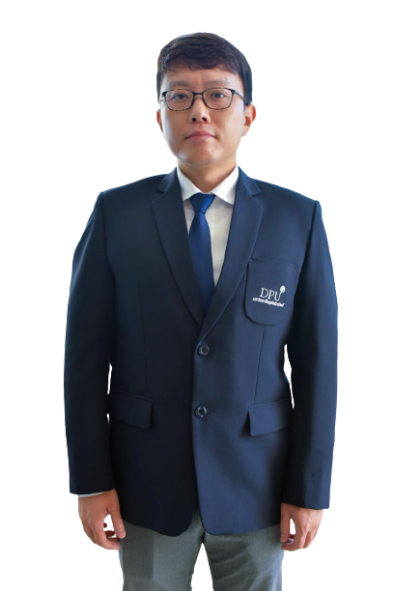

Assistant Professor, Education Management

Deputy Dean of Graduate Programs

China-Asean International College (CAIC), Dhurakij Pundit University

110/1-4 Prachachuen Road, Laksi, Bangkok 10210, Thailand

Tel: +66 2954-7300 Fax: +66 2589-9605

Mobile: +66 950-572-423 E-mail: yuan-cheg.cha@dpu.ac.th

**EDUCATION**

**2015:** Ph.d. in Educational Entrepreneurship and management, National Tainan University of Tainan **2008:** M.S. in Business and Administration, Shu-Te University

**2003:** B.A. in Business Administration, Meiho University, 2003

**AREA OF EXPERTISE**

Aesthetic Experience; Innovation Behavior; Organizational Behavior; Quantitative research

**TEACHING EXPERIENCE (selected list)**

**Full-time Lecturer**

|  |  |
| --- | --- |
| **2016-Presen**  **2014-2016t** | China-Asean International College (CAIC), Dhurakij Pundit University |
| Department of Tourism and Leisure Management, TungFang Design University |
|  |  |

**RESEARCH EXPERIENCE (selected list)**

1. [Chang, Y.-C.](https://www.emerald.com/insight/search?q=Yuan-Cheng%20Chang) & [Jaisook, N.](https://www.emerald.com/insight/search?q=Napawan%20Jaisook) (2020), "Differences in the influence of aesthetic experience on the innovative behaviors of Thai students and Chinese international students",[*Journal of Applied Research in Higher Education*](https://www.emerald.com/insight/publication/issn/2050-7003), Vol. ahead-of-print No. ahead-of-print. <https://doi.org/10.1108/JARHE-05-2020-0133>
2. Chang, Y. C., & Bangsri, A. (2020). Thai students’ perceived teacher support on their reading ability: mediating effects of self-efficacy and sense of school belonging. *International Journal of Educational Methodology*, *6*(2), 435-446. https://doi.org/10.12973/ijem.6.2.435
3. Kong, L. K. and Chang, Y. C. (2019). The effect of teachers’ savoring on creative behaviors: Mediating effects of creative self-efficacy and aesthetic experience. *International Journal of Educational Methodology, 5*(3), 325-335. https:// doi.org/10.12973/ijem.5.3.325
4. Zhao, R. B. and Chang, Y. C. (2019). Students' Family Support, Peer Relationships, and Learning Motivation and Teachers Fairness Have an Influence on the Victims of Bullying in Middle School of Hong Kong. *International Journal of Educational Methodology, 5*(1), 111-121.
5. Chang, Y. C. (2018). Analyzing the moderating effect of knowledge innovation of tourism and hospitality department teachers on student creative self-efficacy and innovation behaviors by using hierarchical linear modeling. *Cogent Education, 5*(1), 1-17.
6. Chang, Y. C., Chou, S. F. and Tsai, Y. T. (2018). *The Influence of Art and Design Students’ Aesthetic Experience on Creative Self-Efficacy and Creativity.* 2018 International Conference on Education and Learning. Waseda University, Tokyo, Japan. August 22-24, 2018.
7. Huang, C. Y. and Chang, Y. C. (2017). The effect of consumers’ ethical decision-making on cosmetic advertising. Academia Journal of Scientific Research 5(12), 672-680.
8. Chang, Y. C. (2017). *Construction on Students’ Aesthetics Experience Scale.* e-CASE & e-Tech , ISBM, ISEP, IConEGS 2017. April 4-6.
9. Chang, Y. C. (2017). Construction on Students’ Aesthetics Experience Scale. *International Journal of Organizational Innovation, 10*(1), 110-130. (EI)
10. Chang Y. C., and Hsiao C. C. (2016). Students’ Aesthetics Experience, Creative Self-Efficacy and Creativity: Is Creativity Instruction Effective. *Journal of Educational Practice and Research, 29*(2), 65-104. (TSSCI)
11. Chang, Y. C., Tsai, C. L., and Chiu, W. Y. (2015). The Influence of Life Satisfaction and Well- Being on Attitude Toward The Internet, Motivation for Internet Usage and Internet Usage Behavior. *Journal of Interdisciplinary Mathematics, 18*(6), 927-946. (EI)
12. Chang, Y. C., Chiu, W. Y. and Lee, Y. D. (2014). Impacts of Knowledge Leadership and the Characteristics of Organizational Structure on Employee Learning Motivation in the Cultural and Creative Industries. *YMC Management Review, 7*(1), 27-42.
13. Chiu, W. Y., Chang, Y. C. and Lee, Y. D. (2014). Impacts of Knowledge Leadership and the Characteristics of Organizational Structure on Employee Learning Motivation in the Cultural and Creative Industries. 2014 International Conference on Logistics, Informatics and Services Sciences. July 2.