**MENG-TIEN CHIANG, MSC.**

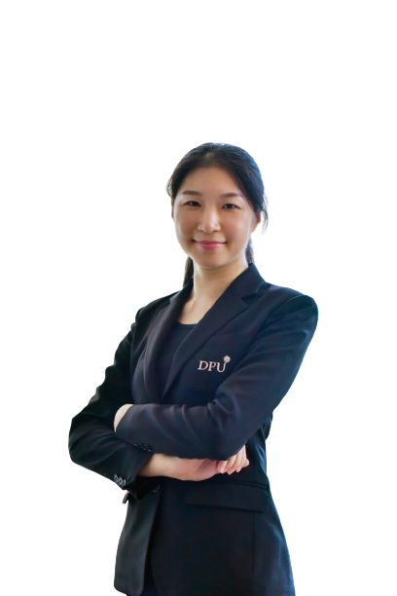

Assistant Director, International Business program

China-Asean International College (CAIC), Dhurakij Pundit University

D’Habitat Ratchaphruek 99/131 Moo 8 Bangkrang Muang, Nothaburi 11000, Thailand

Mobile: +66 98-275-5528

E-mail: meng-tien.chi@dpu.ac.th

**EDUCATION**

**September 2019-Present:** Ph.D. student in Education Management, Dhurakij Pundit University, Thailand

**September 2015:** MSc. Innovation Management and Entrepreneurship,

Bournemouth University, United Kingdom

Dissertation: “Creating a Business Model for an SMEs Travel Agency in Taiwan”

**June 2009:** BBA. International Business Management

Chang Jung Christian University, Taiwan

**SCHOLARSHIPS**

**2019** Doctoral Scholarship at CAIC, Dhurakij Pundit University, Thailand

**AREA OF EXPERTISE**

**Sustainable Development**: Sustainable Development Management

Sustainable Development in ASEAN

Social Sustainability

Sustainability at University

Human Well-being

**Consumer behavior**: Pro-environmental behaviour

Purchase behaviour

Cross-cultural influence

**Marketing:** Green marketing

Innovation/Business Model/Marketing Plan

International Business and Marketing Management

**Education:** Education for sustainable development

Pedagogical Innovation

Game-based learning and gamification/transformative pedagogy

Curriculum Design

**TEACHING EXPERIENCE (selected list)**

**Full-time Lecturer**

|  |  |
| --- | --- |
| **2016-Present** | **China-Asean International College, Dhurakij Pundit University** |
| Undergraduate Sustainability Management  Business Communication  Principle of Accounting |

**RESEARCH EXPERIENCE (selected list)**

* Chiang, M.T., Chen D & Liu F.L. (2020) Exploring the Effects of Consumer Pro-environmental Behaviour in Bangkok, Thailand.

Thai-China research

**PUBLICATION / PROCEEDING (selected list)**

* Wang, L.Y & Chiang, M.T. (2020). Influence of Social Support on Entrepreneurial Self-efficacy and Entrepreneurial Intention of University Students in Hainan, China. *The 2nd China-ASEAN International Conference 2020 & The 2nd International Conference on Tourism, Business, & Social Sciences 2020* (pp. 427-437). Bangkok: Dhurakij Pundit University.
* Chiang, M.T. (2020). Effect of Blended Learning Model on the Autonomy of University Students. *The 2nd China-ASEAN International Conference 2020 & The 2nd International Conference on Tourism, Business, & Social Sciences 2020* (pp. 285-293). Bangkok: Dhurakij Pundit University.
* Chiang, M.T. (2018). Effect of Game-Based Instruction to Chinese College Students Learning in Introductory Accounting. *The 1st International Conferences in Tourism, Business and Social Science, ICTBS* (pp. 26-27). Bangkok: Dhurakij Pundit University.
* Chiang, M.T. (2017). Developing Business Model Innovation: A Case Study of SMEs Travel Agency. *The 2nd International Conference on Economics and Management Innovation* (pp. 109-110). Bangkok, Thailand.