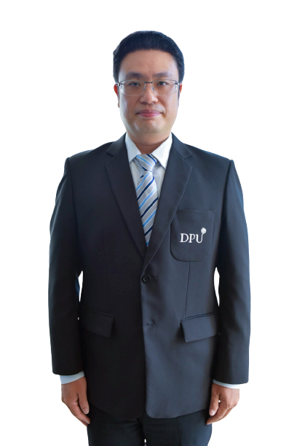**HSIN-CHANG YU, M.B.A.**

Program Director, Finance and Accounting Department

China-Asean International College (CAIC), Dhurakij Pundit University

110/1-4 Prachachuen Road, Laksi, Bangkok 10210, Thailand

Tel: +66 2954-7300 Fax: +66 2589-9605

Mobile: +66080-273-7917 E-mail: hsin-chang.yu @dpu.ac.th

**EDUCATION**

**Jan 2010:** Master of Business Administration, Graduate School of International Business Administration, Chinese Culture University

**June 2002:** Bachelor of business management

Chinese Culture University

**AREA OF EXPERTISE**

**Finance**: Financial literacy

**Sustainability**: Sustainability management

**Financial Education:** Financial Education Curriculum; CSR Education

**TEACHING EXPERIENCE (selected list)**

**Full-time Lecturer**

|  |  |
| --- | --- |
| **2015-Present** | China-Asean International College (CAIC), Dhurakij Pundit University |
|  |
| **2010-2015/06** | Jinwen University of Science and Technology /Department of Finance / Lecturer |

**RESEARCH EXPERIENCE (selected list)**

**2017** Researcher, Research Department of Business Develop and Policy, CDRI, Taipei, Taiwan

**PUBLICATIONS/PROCEEDING**

* Chen, G. C., Yu, H. C., & Chen, D. Evaluation Of Financial And Business Performance Of Non-Life Insurance Industry In Taiwan-An Application Of Multivariate Statistics
* International Conference on Management and Social Science (MSS2016)
* Chen, G. C., Yu, H. C., & Chen, D Social Economic Development and Violent Crime
* The 2nd China-ASEAN International Conference (CAIC 2020) & International Conference on Tourism, Business, and Social Sciences (ICTBS 2020), Bangkok Thailand
* Yu hsin-chang; Xi Chang Huang “The Relationship between Social Support and Life Satisfaction of the Chinese University Students' Study in Thailand: The Mediation of Self-efficacy”