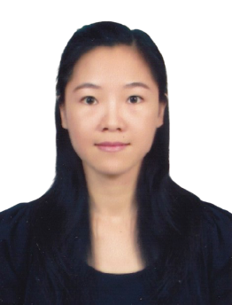 **LINGFEN MO, M.A.**

Instructor and Researcher

Research Innovation and Development (RDI), and

China-Asean International College (CAIC), Dhurakij Pundit University

110/1-4 Prachachuen Road, Laksi, Bangkok 10210, Thailand

Mobile: +66 968862857

E-mail: lingfen.mo@dpu.ac.th

**EDUCATION**

**May 2017:** Communicative Thai as a Second Language

Huachiew Chalermprakiet University, Thailand

Thesis: “Family Problems in Thai Society: Reflection from Thai Novels during 1965-2014”

**June 2011:** Thai Language (National Base Class)

GuangXi University for Nationalities, China

**AREA OF EXPERTISE**

**Language and culture**: Thai and Chinese language and culture

**TEACHING EXPERIENCE (selected list)**

**Full-time Lecturer**

|  |  |
| --- | --- |
| **2018-Present** | **China-Asean International College (CAIC), Dhurakij Pundit University** |
| Undergraduate: Healthy and Happy Life  ASEAN and cross-culture communicative |