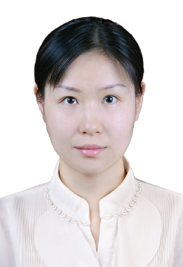**DR. LIN ZHU**

Lecturer of Art and Design, Researcher

Research Innovation and Development (RDI), and

China-Asean International College (CAIC), Dhurakij Pundit

University, 110/1-4 Prachachuen Road, Laksi, Bangkok 10210, Thailand

Tel: +66 2954-7300 Mobile: +66 94-152-3606

E-mail: lin.zhu@dup.ac.th

**EDUCATION**

**July 2017**  D.F.A Visual Art Design  
 Burapha University, Thailand

**July 2010** M.F.A Visual Art Design and New Media  
 Northwest University (Xi’An), China

**July 2008** B.A Graphic Design  
 Northwest University (Xi’An), China

**SCHOLARSHIPS**

**Sep 2009** Northwest University (Xi’An) 1st Grade Scholarship

**Sep 2007** Northwest University (Xi’An) Academic Scholarship (Full-tuition)

**Sep 2006**  Northwest University (Xi’An) Academic Scholarship (Full-tuition)

**Sep 2005**  Northwest University (Xi’An) Academic Scholarship (Full-tuition)

**AREA OF EXPERTISES**

**Communication** : Cross-cultural communication

**Education:** Fine art design

**TEACHING EXPERIENCE (selected list)**

|  |  |
| --- | --- |
| **2017-Present**  **2011-2014** | Full-time Lecturer  CAIC, Dhurakij Pundit University, Bangkok, Thailand  Full-time Lecturer  Xi’An International Studies University, China |
|  |

**RESEARCH EXPERIENCE (selected list)**

* Creative concept poster design of Covid-19.

The 2 nd International Art &amp; Design Collaborative Exhibition 2020 (IADCE 2020).

* Canon Camera Concept Display Shop Design

The 1st International Art & Design Collaborative Exhibition 2019 (IADCE2019)

* Application Research of Interaction Design Concept in Children's Medicine Innovative Packaging Design.

The 1st China-ASEAN international Conference2019 (CAIC)

* The Application of New Multimedia Innovation in Humanities Museum

International Conference on Social Sciences, Arts and Humanities 2017

* User Interface Design On Mobile Application For Consumer Perception Plan In Thailand To Chinese Tourism: Case Study Of Central World. Doctoral Thesis 2017