**FEI ZHAO, M.A. (MAGISTER ARTIUM – GERMANY)**

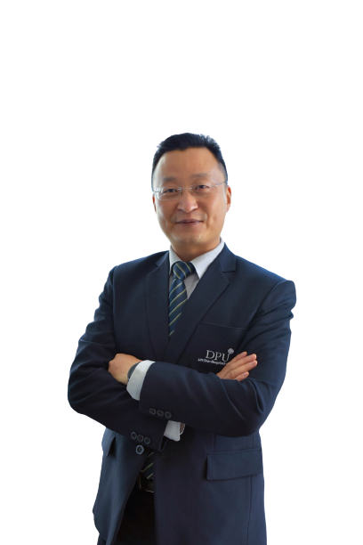

Instructor and Researcher

Research Innovation and Development (RDI), and

China-Asean International College (CAIC), Dhurakij Pundit University

110/1-4 Prachachuen Road, Laksi, Bangkok 10210, Thailand

Tel: +66 2954-7300 (831) Fax: +66 2589-9605

Mobile: +66 95-772-7887 E-mail: fei.zha@dpu.ac.th

**EDUCATION**

**Sep. 2006 – Jul. 2009** Master of Political Science, Economic Science and Economic and Social History; Institute of Social and Behavioral Science

Friedrich-Schiller-University, Germany

**Apr. 2002 – Jul. 2006:** Bachelor of Political Science, Economic Science and Economic and Social History; Institute of Social and Behavioral Science  
Friedrich-Schiller-University, Germany

**AREA OF EXPERTISE**

**NEW INSTITUTIONALISM AND BEHAVIORISM**:

Actors, their behaviors, and interactive Impact in Business Cooperation under cultural Institutionalism

Factors study for Success and Failure in international cooperation program – Implementation of German economic development program in ShanXi, China

**CROSS CULTURE FACTORS IN SINO-THAI BUSINESS COOPERATION:**

Management Difficulties and Dilemmas of Chinese Direct Investment in Thailand

**DUAL EDUCATION SYSTEM OF VOCATIONAL EDUCATION IN GERMANY:**

Practice and Case Study of German Vocational Education Cooperation in China

**ELDERLY CARE POLICY AND INDUSTRY IN CHINA AND THAILAND:**

Advantage of Thailand as a consume destination of elderly care service

Form of Elderly Care in China under impact of Chinese cultural value

Factors Study for Chinese Elderly Care Consume in Thailand

**TEACHING EXPERIENCE (selected list)**

|  |  |
| --- | --- |
| **2016-Present** | **China-ASEAN International College, Dhurakij Pundit University, Thailand** |
| Undergraduate: Science and Technology for Quality of Life and Society  Business Analysis and Planning  Eastern and Western Views and Values |
| **2015-2016** | [**Department of Business Chinese**](http://www.au.edu/study-programs/undergraduate-programs/81-arts-1/1778-department-of-business-chinese-1.html)**, Assumption University, Thailand**  Undergraduate: Business Chinese II  Business Writing III  Advanced Economic Chinese II  Special Study for Graduation Students |
| **2009-2014** | **College of Tourism and Foreign Language, JiangSu Vocational Institute**  **of Commerce, Nanjing | China** |
| Undergraduate: Introduction to European Union  Introduction to Modern Germany  Fundamental German I, II  Intermedium German  Economic German  Business German  Scientifical and Technological German  Special Study –Volks-Wagen Factory in Shanghai as a successful   Sino-German Jiont-Venture  Coaching for Graduation Thesis |

**RESEARCH EXPERIENCE**

* Yong Li, Fei Zhao, Xichang Huang and Lu Zhang, No Fear Investment: A Study on Collar Strategy, The 2nd China-ASEAN International Conference (CAIC 2020) and The 2nd International Conference on Tourism, Business, & Social Sciences (ICTBS 2020), Bangkok, Thailand, 2020, P75-82
* WEI, L.W, ZHAO, F. HUANG. X.C. LI, M.H., An Investigation into the Determinant Causes of Stress and Stress Level of Chinese College Students in Bangkok Thailand, presented at the 1st China-ASEAN International Conference (CAIC 2019): Insight to Chinese and ASEAN's Experience and Adaptation <http://www.dpu.ac.th/caiconf/venue.html>
* Zhao. F., & Zhao. Z, Quantitative Analysis of the Quality of Teaching of Applied German through PGG4, Journal of Jiangsu Vocational and Technical Institute of Economics and Commerce, (2012) 2.
* Zhao. F., & Zhao. Z, Employment Prospects and Countermeasures of German Specialized Talents in the Yangtze River Delta Area. Science & Technology Information, (2011) 7.